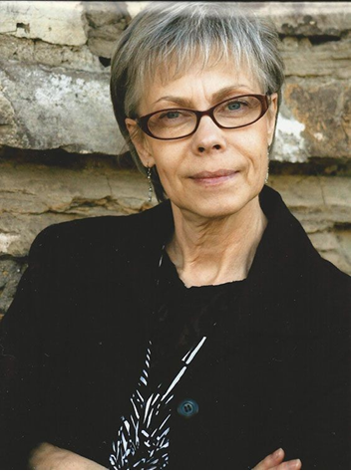
Join us for this FREE!
In-person workshop with Rebecca Tree
Applying Loose Parts and Schema Theories in 21st-Century Early Learning Classrooms
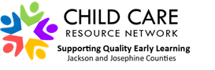
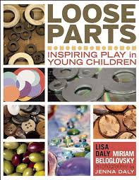
Space for 28 people – attendance will include a free copy of the Loose Parts book by Lisa Daly and Miriam Beloglovsky
Participants will examine the hand/brain connection, Loose Parts and Schema as theoretical foundations in early learning growth and development. As a group we will examine its application and sustainability and test assumptions we may have. This hands-on workshop will encourage interacting with Loose Parts and comparing and contrasting differences and functions. You will have the opportunity to examine Schema as a tool that assists in organizing and interpreting children's play, helping to build engaging opportunities and enhancing learning.
Rebecca Tree has worked in the early childhood community for over 35 years. First as the founder and director of a non-profit program in Medford, Oregon and currently as the Director of the Community Preschool of SOU. She also serves as adjunct faculty in the Early Childhood Development department. Ms. Tree received her master’s in education from Southern Oregon University at the age of 62, proving that learning is a life-long endeavor and as long as we breathe, we should be engaged in meaningful work.
Questions? Please contact ccrn@soesd.k12.or.us
Saturday, October 28
9:00am-1:00pm

Workshop to be held in-person at SOU in Ashland in the Education/Psychology building on S. Mountain Avenue next to the Plunkett Center. Parking on street.
To register:
Use the CCRN training registration online form or phone line:

CCRN Online Training Form
Training line: 541-776-6768

