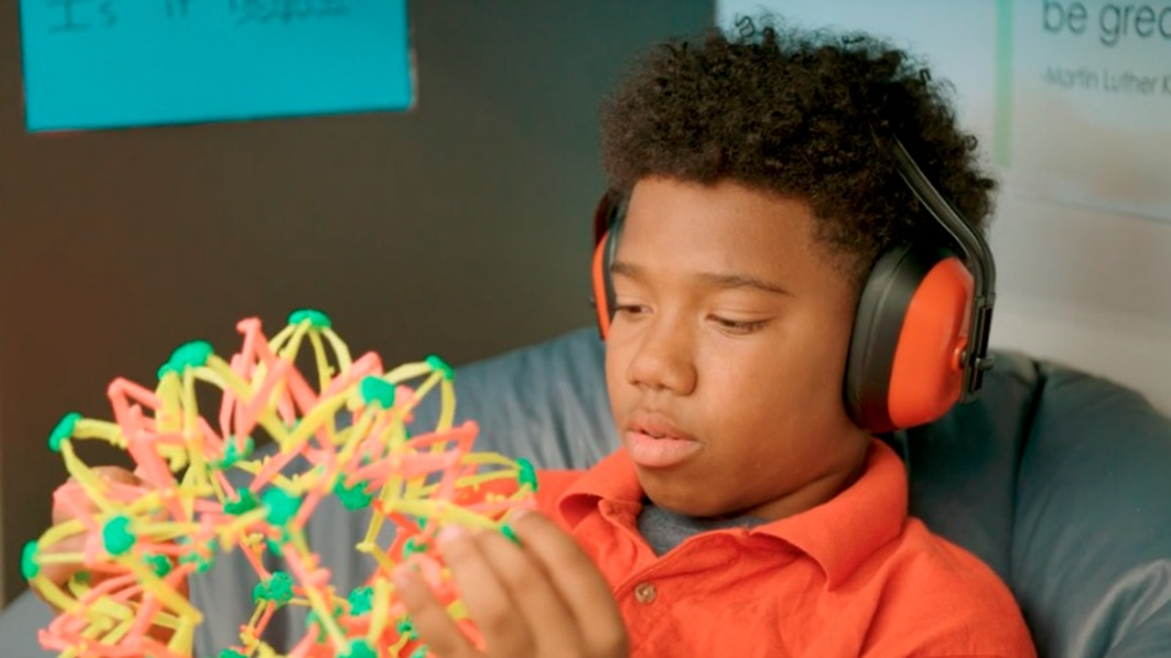  - creating a “calming space”  in your early learning environment      During this training, we will discuss why it is important to have a quiet space for children to retreat to when they are overwhelmed. After completing this training you will know how to create calming space on any budget, what items to include in this area, and how to introduce them to your class.
  Monday, November 12th
  ____
  6PM-8PM
  ____
  FREE Training!
  ____
  2 hours in LEC
  ____
  Contact Abbie to RSVP at
  541-410-0950
  Training Location:
  Inspire Early Learning centers – West!
  929 SW Simpson Ave #130
  Bend, OR
  541-410-0950

